It was multiple techniques used in this lab, started with passive hacking, looking for footprints on google gathering information getting the company’s web data and looking for their domain. The second step was networking to identify live host, open ports, and tags services. Ended up with enumeration to extract usernames, machines names and network resources, etc.
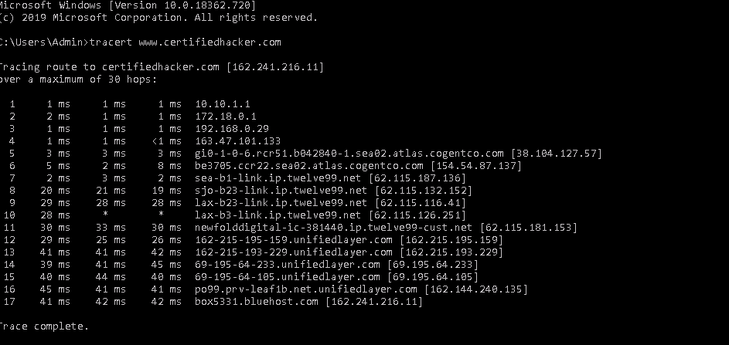
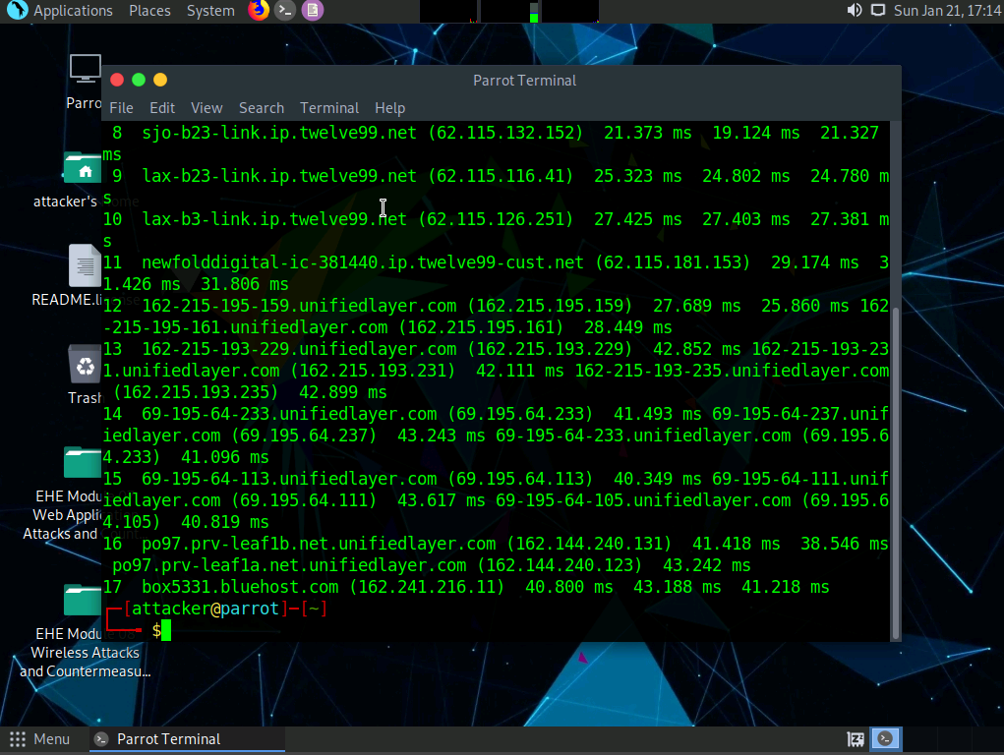
Using more than one tool for scans or enumerations in cybersecurity offers several advantages. Firstly, diverse techniques employed by different tools enable a broader coverage of vulnerabilities and potential security issues. Each tool may excel in specific areas, contributing to a more comprehensive assessment. Additionally, the redundancy introduced by multiple tools reduces the risk of overlooking critical security issues, enhancing the overall reliability of the assessment.
- What worked well in the lab?
The best pert of the lab was enumeration on the BIOS, using the commands lines and then uses NetBIOS Enumerator which I still do get exactly the tool function.
- What parts were troublesome?
The only part I had trouble was ab 2 Part 4 using the unicornscan I was typing (unicornscan [Target IP Address] -lv) ad I should type (unicornscan [Target IP Address] -Iv). I had a little trouble figuring out that error.
- Over all impression of the lab?
I liked the lab in how can tools can be helpeful to scanning, tracking and finding information using just basic knowledge and information provide from google.

